Meeting 11-5-2017

The issue that I have been working on solving involved the work-loops looking funky when I would fun them with the piecewise isometric calcium transient. To figure this out, Andre helped me fit the isometric calcium transient. Below is the fit:

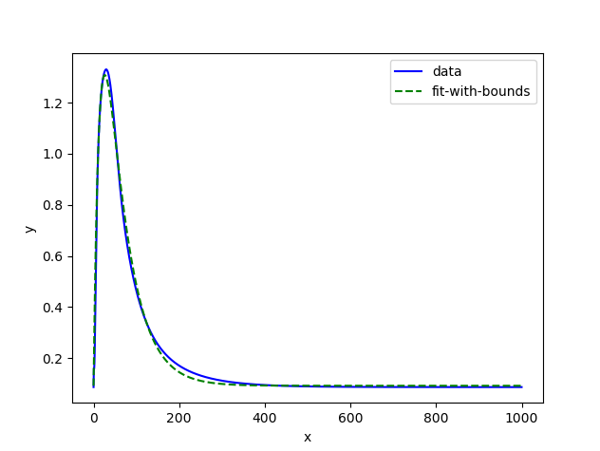





How do you keep track of changes, variables, I am finding it so hard to trust what I am doing. If I make notes I can’t seem to find them later or I don’t know what is going to be significant.

Bottom figure🡪 I am not sure why the Isometric bars look the way they do/ is there some variable or parameter change that is responsible for these results.